Courses | How to find courses with english as teaching language
- If HISinOne is used with the 'English' user interface:
Choose 'Studies offered' → 'Search for courses'
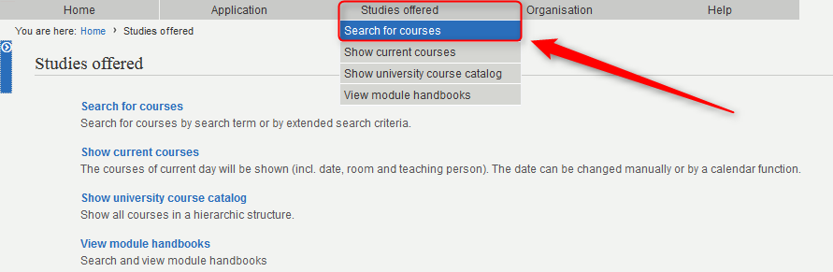
- switch to 'show all possible search criteria'
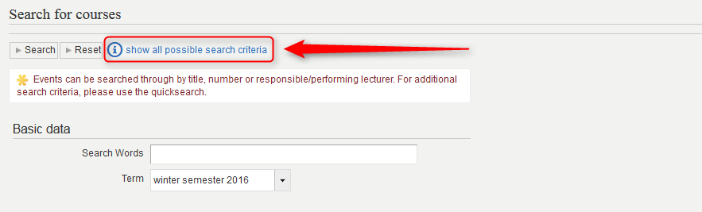
- choose 'english' in 'Teaching language'
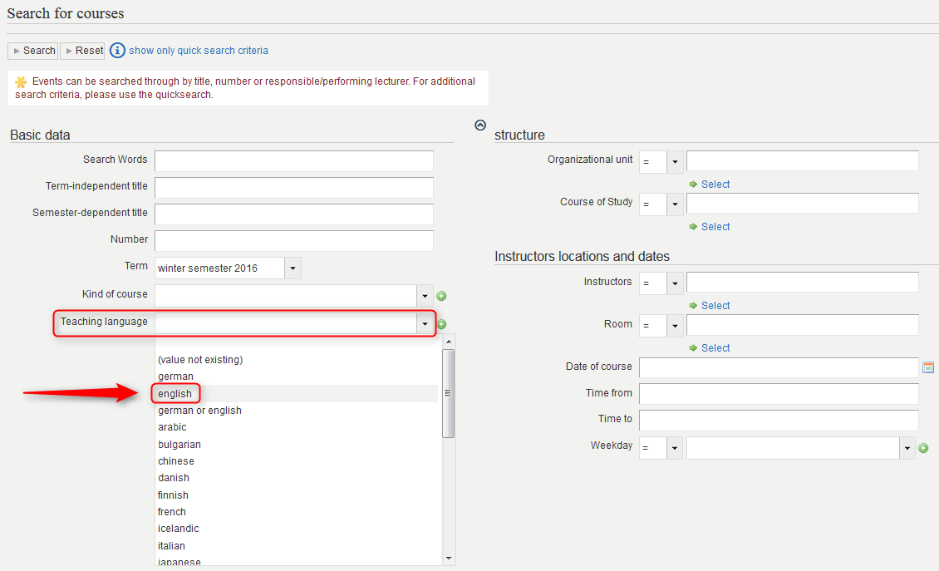
- find 439 courses in WS 16/17


